

**Software Engineering Group Mini-Project 2019**

**GROUP 2 - DVD STORE MANAGEMEN­T SYSTEM**

**CSC312**

Dr. Michael Norman, Professor

Contents

Preface 4

Target Audience 4

Roles & Responsibilities 4

1. Introduction 6

1.1 Scope 6

A. Purpose and Aim 7

B. Objectives 7

C. Requirements 8

D. Assumptions 15

E. Constraints 15

F. Interface type 15

G. Interaction modes 15

H. Benefits 16

I. Business rules 16

J. Project exclusions 16

1.3 Definitions, Acronyms and Abbreviations 17

2. Planning 17

2.1 Process model 17

A. Agile Scrum 17

B. Pros & Cons 19

2.2 Tasks to be done 19

2.2 Reflection 20

3. Modelling Analysis 20

3.1 System Architecture 20

A. Class Diagram 20

B. Class Descriptions 21

C. Activity Diagram 25

3.2 Database design 26

A. ERD 26

3.3 System Model 27

3.3.1 Use case diagram 27

4. Construction 28

4.1 Actor Descriptions 28

A. Actor: Viewer 28

B. Actor: Customer 29

C. Actor: Clerk 31

C. Actor: Manager 32

4.2 Use Cases 35

A. Register 35

B. Login 36

C. Rent DVD 37

D. Update/View Customer information 39

E. Checkout 39

F. Check-in 41

G. View reports 41

H. Add DVD 42

I. Remove DVD 43

J. Add User 44

K. Remove User 45

5. Deployment 45

5.1 Delivery/installation information 46

5.2 Test Login Details 46

6. Appendix 47

Appendix A: Screens 47

A.1 Viewer Workflow: 47

A.2 Customer Workflow: 48

A.3 Clerk Workflow: 49

A.3 Manager Workflow 51

Appendix B: Code 55

B.1 Models (Database tables): 55

B.2 URLS: 56

B.3 Views: 57

# Preface

Within this document there lies a high level description of the requirements, designs and procedures taken to develop a computer application for a DVD store management system.

It describes in full detail the architecture and system design of the DVD store management system.

# Target Audience

Designers of this project, Clients and moderators (Lecturer/s)

# Roles & Responsibilities

|  |  |  |
| --- | --- | --- |
| **Name** | **Role** | **Responsibilities** |
| Jean Luc Iradukunda 3647875 | Project Manager (Scrum master) | * Activity and resource planning * Organizing and motivating project team. * Controlling time management * Monitoring progress * Ensuring that tasks remain within defined scope |
| Ziyaad Lakay  3647623 | Front-end Developer (Lead) | * Ensuring good HCI principles are adhered to * code the user interface * ensuring responsive user interface design principles * defining, designing, and executing usability testing of the website/ web-application |
| Uzair Jones  3687046 | Back-end Developer (Lead) | * Adding functionality to the front-end components * Design the system architecture * Collaborate with Front-end developers * Troubleshoot and debug applications |
| Keelan Govendar  3770037 | Database developer | * Design, develop, test, implement Database * Define database corresponding documentation * assistance the team in topics related to data management |
| Jared Cupido  3729602 | Database Developer | * Design, develop, test, implement Database * Define database corresponding documentation * Modifying databases and products according to client needs |
| Michael Arendse  3756810 | Back-end Developer | * Create methods that support the system * optimize performance * Document system architecture * Define and communicate technical requirements |
| Timo Michiels  3603151 | Front-end Developer | * Designing and creating the interfaces * Building high-quality mockups and prototypes |

# 1. Introduction

This is the requirement gathering analysis document for the DVD store management system project.

## 1.1 Scope

Here in the scope of the entire project will be described, for the purposes of this document; a clerk is a front-desk DVD store employee, a manager is the manager of the DVD store and a customer defines the people who rent DVDs from the store.

### A. Purpose and Aim

The aim of the DVD store management system project further detailed in subsequent sections of this document is to produce a highly suitable software solution that will possess all capabilities necessary to efficiently operate a DVD rental store such as managing rentals and producing concise reports. This software solution will be in the form of a web application that will allow a DVD store to manage and keep record of their day-to-day transactions. This will be achieved by designing practical user interfaces, system architecture and databases.

Once logged in users will then have access to personalised system functions based on user type, the menu will be responsive, showing different options to the different type of users. Employees (clerks) will be able to manage DVD rentals and DVD returns on the other hand managers will be able to perform all the functions of the clerk as well as managing customer accounts, having direct access to the database and being able to view system reports . Customers will be able to use the website to browse through a catalogue of DVD selections, they will be presented with details about each movie and will have the option to book a DVD to which the can then go to the store and redeem after paying settling the rental cost.

### B. Objectives

The key objectives of the project are as follows:

#### B.1 Quality:

Quality of the system will be maintained primarily through formal reviews by all team members at each level of the project, these reviews will cover processes, procedures and work produced by each team-member and the entire team as whole. Further quality assurance will be achieved by means of a multi testing approach whereby the project team will use various to testing approaches to assure the quality of the system.

#### B.2. Performance:

The systems performance will be ensured through well-defined documentation of system functions and even better defined system expectations that will meet all user goals.

#### B.3. Security:

The clerk, manager and customer will all have to login into the system with their unique login details (username and password). After user has provided the correct login details the system will provide a view of the system corresponding to the user type.

#### B.4. Ease of Use:

* Clerks and managers with limited technical knowledge should be able to view and update the data.
* Learning to use the system should be easy for all users.
* Any person with basic experience with computers should be able to learn to use the system in a reasonable amount of time and with little help or tutelage.
* A user manual and/or help directory should be supplied for users. Slightly different versions will be available for each type of user.

#### B.5 Robustness:

The system will be tested extensively and will designed to handle all exceptions possible on the system. System will provide corresponding feedback based on the exception occurring and also require verification before writing to the database to avoid incorrect records being stored.

#### B.6 Availability:

The system will be available at all times with users able to view DVD offerings at any time, as for renting and returning of DVD’s, that will only be possible during the hours that the DVD store is open.

### C. Requirements

#### C.1. User Requirements:

Customer:

* Each customer will have a username.
* Each customer will have a password.
* Each customer has unique user ID generated by the system.
* Each customer will have a first name and a last name.
* Each customer will have an email.
* Each customer will have an address consisting of street address, suburb, city and postal code.
* Each customer’s ID number will be stored.
* Each customer will have a phone number.
* Each customer will be identified as non-staff.
* Each customer will be identified as not a Superuser.

Clerk

* Each clerk will have a username.
* Each clerk will have a password.
* Each clerk has unique user ID generated by the system.
* Each clerk will have an email.
* Each clerk will have a first name and a last name.
* Each clerk will be identified as staff.
* Each clerk will be identified as not a Superuser.

Manager

* Each manager will have a username.
* Each manager will have a password.
* Each manager has unique user ID generated by the system.
* Each manager will have an email.
* Each manager will have a first name and a last name.
* Each manager will be identified as staff.
* Each manager will be identified as a Superuser

DVD

* Each DVD copy has a unique DVD ID.
* Each DVD copy will have a title (movie), year, genre, image and synopsis.
* Each DVD copy will be identified as either in stock or not.
* Each DVD copy will have a booking pickup associated with a customer.
* Each DVD copy will have a price.

TRANSACTION:

* A transaction occurs when customer checks out DVD, each transaction is unique and will have a unique transaction number.
* Each rental is made by exactly one customer.
* Each transaction will have a rent and due date.
* Each transaction will have a movie title.
* Each transaction will have an amount describing the total cost to the customer for the rental duration.

#### C.2. Functional Requirements:

* The system will provide registration for viewers to become registered customers.
  + The system will generate and assign a use ID to a registered customer and give them options to enter their information and password.
  + The system shall record customer information and store it in the database.
* The system shall allow customer to search for movies.
* The system shall allow customers to view and modify their information.
* The system shall provide login security for DVD bookings by customers.
* The system shall provide login security for checking in/out DVDs by clerks.
* The system shall calculate the total bill of a before checkout.
* The system shall allow the manager to add new DVDs to the inventory.
* The system shall allow the manager to remove DVDs from the inventory.
* The system shall allow the owner to modify DVD and user details.
* The system shall allow the manager to add new users.
* The system shall allow the manager to remove users from the database.

#### C.3. Non-Functional Requirements:

* The customer view of the system will be accessible to all viewers with limited functionality available to registered users.
* Payment must be made before clerk can checkout movie
* Clerk cannot remove/add other employee accounts
* The system shall provide continuous storage for membership, rental, and video inventory information in the database.
* The system shall provide an intuitive user interface that requires no training.
* The system shall provide meaningful responses to users based on the context of the users’ actions.
* The access rights of the system can only be changed by the manager.
* The system will provide a message if a customer movie search is unsuccessful.
* All transaction, users and DVDs in the inventory will be viewable only by the manager.
* The system interface will contain concise content navigation buttons and menus.

#### C.4 .Data requirements:

##### C.4.1 User Data

The user data describes details of the users of the system including names and password.

|  |  |  |
| --- | --- | --- |
| **Data Field Name** | **Description** | **Example** |
| userID | A unique integer that represents the user, it is incremented by 1 from 0 every time a user is added to the system. | *12* |
| Name | The first name of a user. | *John* |
| Surname | The last name of a user. | *Doe* |
| Username | Identification that will be used to identify a user at login and throughout the system. | *JohnDoe97* |
| Email | Email address of user. | *johndoe@gmail.com* |
| Password | A secret phrase or combination of characters that a user will need to provide to gain access to the system. | *10PmSS@is97!#* |
| Is_Staff | A Boolean that identifies a user is a staff member or not, set only by the manager. | *True* |
| Is_Superuser | A Boolean that identifies a user is a super user (manager). | *False* |

##### C.4.2 Customer Data (Extends User data)

|  |  |  |
| --- | --- | --- |
| **Data Field Name** | **Description** | **Example** |
| Address | The residential address of the customer | *No.4 Sonroy center, Sandton, 7825* |
| PhoneNumber | The telephone number of the customer | *0611917594* |
| Identification | Identification Number of the customer | *9512115678931* |
| User_ID | A unique integer that represents the user, it is incremented by 1 from 0 every time a user is added to the system. | *12* |

##### C.4.3 DVD Data

|  |  |  |
| --- | --- | --- |
| **Data Field Name** | **Description** | **Example** |
| DVDID | A unique integer that represents the DVD, it is incremented by 1 from 0 every time a DVD is added to the system. | *1* |
| Title | The movie title of the particular DVD. | *John Wick* |
| Year | The year which the movie was released. | *2018* |
| Genre | The genre under which the movie is categorised. | *Action* |
| InStock | Defines whether the movie is in stock or not. | *True* |
| Synopsis | Short description of the movie. | *Jack and Jill is the story of a boy and a girl who went up a hill together. They went to fetch a pail of water, but unfortunately, their plan is disrupted when Jack falls and hits his head, and rolls back down the hill* |
| BookingPickup | The name of the customer who booked the movie. | *Jean* |
| NumOfTimesRented | The total number of times the movie has been rented | *20* |
| PriceDVD | The price for renting the DVD for a day | *R50* |
| ImageDVD | The cover of the movie. | C:\Users\User\Downloads\download.jpg |

##### C.4.1 Transaction Data

|  |  |  |
| --- | --- | --- |
| **Data Field Name** | **Description** | **Example** |
| users_ID | A unique integer that represents the user, it is incremented by 1 from 0 every time a user is added to the system. | 12 |
| TransactionNumber | Unique integer generated by the system. | 120 |
| dvdID | Unique integer that represents the DVD. | 1 |
| RentDate | Date upon which the DVD was rented. | 2019-09-14 |
| DueDate | Date upon which the DVD is to be returned. | 2019-09-16 |
| MovieTitle | The movie title of the particular DVD. | Jon Wick |
| Payment_Method | Cash or card | card |
| Amount | Total cost of the rental bill. | R50 |

### D. Assumptions

Here below are the project assumptions, these are things that we as the project team believe to be true in order for the DVD store management system to be successful.

|  |  |
| --- | --- |
| **Category** | **Assumptions** |
| Scope | * Scope will remain mostly the same with minor changes/improvements based on tests performed at various later stages in the project |
| Methodology | * Project will follow the Agile methodology |
| Technology | * Software will be developed using the Python-Django framework * Software the team will use to develop the project includes: Slack, Trello, Visual Studio Code and Github. |
| Design approach | * Design approach will be evaluated for efficiency at various stages of the project and changes will be added if necessary |
| Resources | * People will not need training to use the system, on screen prompts will be enough to direct customers on what to do. |
| Database | * The DSMS will processes SQL statements to populate all necessary database tables and also be able to read from these tables. |

### E. Constraints

* Credit card Payments will be handled and computed buy third party vendor, thus a failure on their end will lead to a failure of system workflow
* Any failure due to internet connectivity will result in total system shutdown

### F. Interface type

Graphical User Interface (GUI)

### G. Interaction modes

**Instructing:** user tells system what to do, by typing commands, selecting menu options, pressing keys or buttons, speaking commands

**SEARCHING (conversing):** user has dialogue with system; typing questions and/or responses, or uses speech input/output

**Manipulation:** user interacts with physical or virtual objects, e.g., holding, moving, opening, closing; object is a focus of attention

### H. Benefits

Tangible benefits

* Elimination of paper work
* Increase response time
* Reduction in processing error
* Faster service time
* Elimination of job steps
* Increase in profit

Intangible benefits

* Improved decision making
* Increase in competitiveness
* Increase customer base
* Improved resource management
* Improved customer service

### I. Business rules

* DVD cannot be booked for more than 24 hours
* Multiple users can access the system simultaneously.
* Username is unique to each user, no 2 users may possess the same username.

### J. Project exclusions

This here is a listing of services and options that the team will not be delivering in the project. This is to further serve as a guide to what the system will and will not be able to do so that there is no confusion.

* No user training will be implemented
* Credit card authentication will not be performed by the system

## 1.3 Definitions, Acronyms and Abbreviations

|  |  |
| --- | --- |
| DSMS | DVD Store Management System |
| DVD | Digital Versatile Disc |
| Manager | Oversees all store operations. |
| Clerk | DVD Store employee, responsible for checkout and check-in of DVDs |
| Customer | Registered user of the system, member |
| Staff | Refers to both the Clerk/s and manager of the DVD store |
| Superuser | Refers to a user who has advanced read and write access with regards to the database and certain system views (being able to view confidential reports) |
| Transaction | Rental or checkout of a DVD by customer |
| Viewers | Non-members, not yet registered customers |
| Screen (e.g Home screen) | Refers to a webpage. |
| Home page | This view refers to the landing page for the customer which showcases the catalogue of the DVDs in the store. |

# 2. Planning

## 2.1 Process model

### A. Agile Scrum

The reason why we chose to work with the agile methodology is because after thorough assessment of other possible methodologies like the waterfall and V-models. Agile scrum stood out as it would grant us as a team the greatest ability to move quickly and easily. It provided a flexible foundation of concepts and beliefs that we would allow us as a team to make better decisions with regards to developing the software. By means of agile we were able to prioritize tasks and procedures according to fit our resource and time constraints.

Another contributing factor to our decision of choosing the agile methodology was the wide variety of Agile project management software which we heavily used in the form of a software application named Trello. Trello allowed us to assign tasks to individual members in the project and keep track of what was being done, by who and when the tasks were completed.

We aimed to be systematic and disciplined at every level of the project through various means and making use of available industry leading technologies. Some of these technologies being the use of version control that allowed us to achieve unprecedented collaboration. Along with using agile project management software, version control for collaborative software development, we also made use of slack (a cloud-based collaboration tool) that allowed for more effective communication and allowed us to integrate our other tools as well.

Tools used include the following:

* Slack
* Trello
* GitHub – store our entire code base
* GoogleDrive – to store all project related documents
* Django (python framework that allows integration with HTML and CSS)
* Pythonanywhere.com – allowed us to host our site
* Visual Studio code editor

Methods we implemented include but were not limited to the following:

* Requirement gathering

To add value to our requirements we interviewed the manager of The Village DVD (<http://www.thevillagedvd.com/>) store.

* System design

Approached with the goal of building a sophisticated backend while maintaining a user-friendly and functional frontend

The umbrella activities that we touched upon during the project include:

* Software project tracking and control:

This was achieved by use of GitHub and Trello.

* Quality assurance:

Every segment of code written had to be first be tested extensively, after testing the code had to go through mandatory technical reviews by at least 3 members of the team before it could be merged into the code base. This allowed us to maintain the quality of software and allowed the entire team to be up to date with all the changes that were being made/developed.

We ensured reusability through system tests performed by all members of the team on their respective varying development environments.

### B. Pros & Cons

Pros:

* Ease of change and management of change. The agile-scrum methodology allowed to continuously improve and change what we were creating.
* Fast paced review cycles that made spotting errors quicker.

Cons:

* Due to the fast pace of the workflow some team members would fall behind and have a lack of understanding.
* It became challenging to also manage team while trying to integrate all the necessary skill sets required to complete the project.
* Results of the work being produced could at some points become unpredictable due to the ever changing nature of the methodology.

## 2.2 Tasks to be done

Week 1 – Define Functional and Non-functional requirements, research what stack to use

Week 2 – Class Diagram and Use case Diagram

Week 3 -

* Requirements gathering.
* planning documentation (JI)
* Data and functions
* Updates on class diagrams
* Mocking of UI
* activity diagrams
* pseudocode

Week 4-5 – Coding

2.2 Reflection:

# 3. Modelling Analysis

## 3.1 System Architecture

### A. Class Diagram

### B. Class Descriptions

##### A.1 Class: Users

|  |  |
| --- | --- |
| **Name** | Users |
| **Description** | The user class captures all users shared attributes. |

**Attributes**

|  |  |  |
| --- | --- | --- |
| **Name of Attribute** | **Data Type** | **Description** |
| userID | int | Number generated by the system and assigned to users in chronological order. |
| username | String | Alphanumeric characters supplied by the user to be used as their unique identifier. |
| email | String | Supplied by user |
| phonenumber | String | Supplied by user |
| password | String | Supplied by user |
| Firstname | String | Supplied by user |
| lastname | String | Supplied by user |
| isStaff | Boolean | Supplied by system, modifiable only by the manager |
| isSuperUser | Boolean | Defines managerial access rights |

**Methods**

|  |  |
| --- | --- |
| **Method Signature** | **Description** |
| getID() | Public method that returns the an integer ID. |
| Login() | Processes login transaction. |

**Relationships**

|  |  |
| --- | --- |
| **Class Name** | **Type of relationship** |
| Manager | Inheritance |
| Clerk | Inheritance |
| Customer | Inheritance |

##### A.2 Class: DVD

|  |  |
| --- | --- |
| **Name** | DVD |
| **Description** | The DVD class captures all DVD shared attributes and contains methods to modify these attributes. |

**Attributes**

|  |  |  |
| --- | --- | --- |
| **Name of Attribute** | **Data Type** | **Description** |
| DVD_ID | String | Number generated by the system and assigned to DVD in chronological order. |
| Dvd_title | String | Name of movie. |
| InStock | boolean | Whether the DVD has been rented or not. |
| genre | String | Genre under which the movie is categorised. |
| Synopsis | String | Short description of movie plot. |
| NumberOfTimesRented | int | The amount of times the DVD was rented. |
| bookingPickup | String | Username of the most recent customer to book the DVD. |
| numberDaysBooked | int | Period that the DVD has been in the booked state. |
| priceDVD | Double | Cost of renting the DVD for one day. |
| dvdImage | Image field | Cover of the movie. |

**Methods**

|  |  |
| --- | --- |
| **Method Signature** | **Description** |
| getDVD_ID() | Returns an integer that is the DVD ID. |
| Search_DVD_Name() | Performs the search functionality for finding a DVD based in the Movie name. |
| Add_new() | Void method that adds new DVD into the database. |
| Delete() | Method to delete DVD from the database. |

**Relationships**

|  |  |
| --- | --- |
| **Class Name** | **Type of relationship** |
| Manager | Association |
| Clerk | Association |
| Customer | Multiplicity |

##### A.3 Class: Transaction

|  |  |
| --- | --- |
| **Name** | Transaction |
| **Description** | The Transaction class captures all transaction related details. |

**Attributes**

|  |  |  |
| --- | --- | --- |
| **Name of Attribute** | **Data Type** | **Description** |
| UserID | String | Integer that represents the user |
| rentDate | String | Date upon which the DVD was rented. |
| TransactionNumber | int | Unique integer generated by the system to identify the transaction. |
| dvdID | String | Unique integer that represents the DVD. |
| amount | double | Total cost of the rental bill. |
| dueDate | String | Date upon which the DVD is to be returned. |
| paymentMethod | String | Cash or card |

**Methods**

|  |  |
| --- | --- |
| **Method Signature** | **Description** |
| recordTransaction() | Performs transaction, enters data into database. |

**Relationships**

|  |  |
| --- | --- |
| **Class Name** | **Type of relationship** |
| Manager | Association |
| Clerk | Association |
| Customer | Multiplicity |

### C. Activity Diagram

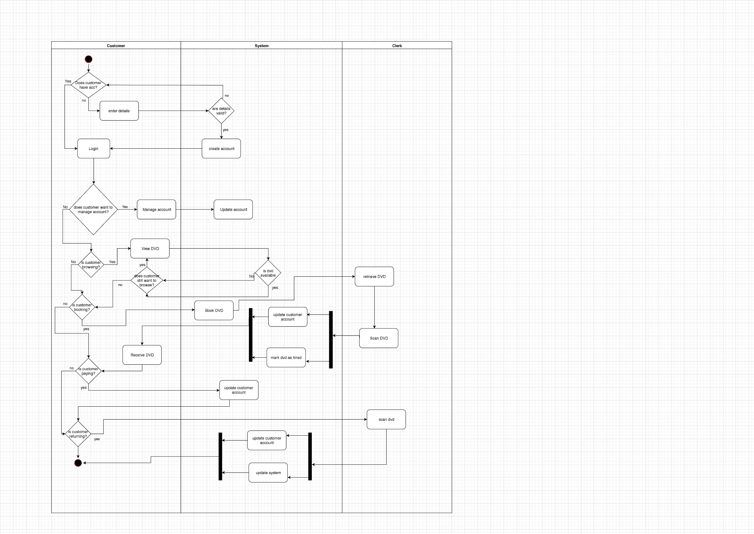

## 3.2 Database design

### A. ERD

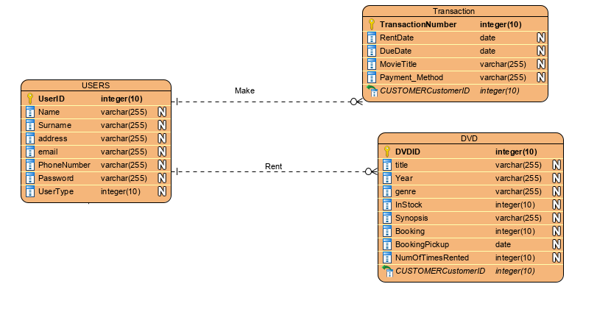

## 3.3 System Model

### 3.3.1 Use case diagram

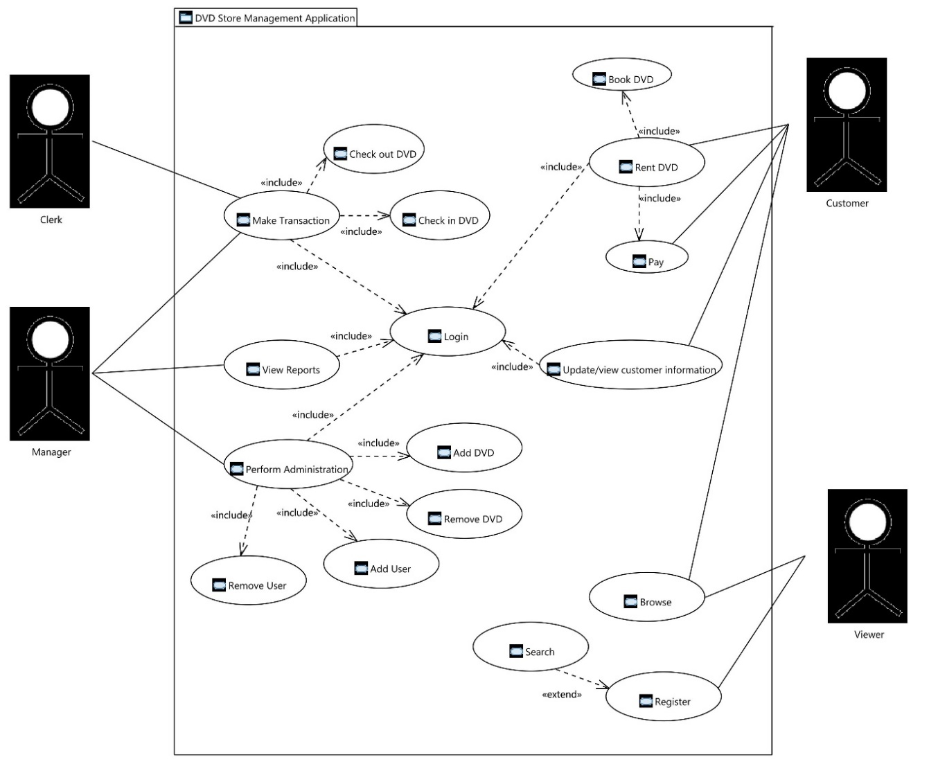

# 4. Construction

## 4.1 Actor Descriptions

### A. Actor: Viewer

|  |  |
| --- | --- |
| **Name** | Viewer |
| **Alternate names** | Non-registered user |

**Input Data**

|  |  |
| --- | --- |
| **Name of Use Case** | **Inputs to the system by user** |
| Browse | No inputs necessary. |
| Register | Viewer details including the following: username, first name, last name, email, ID number, address and phone number. |

**Output Data**

|  |  |
| --- | --- |
| **Name of Case** | **Outputs from the system** |
| Browse | System presents viewer with a catalogue of DVD selections.  For viewer the menu view will have the following options: [Home](http://videohaul.pythonanywhere.com/), Categories, My details, Register and Login. |
| Register | System responds with message. Letting the viewer know that the registration was a success or not. |

**Description**

A user who has not yet registered, possessing limited access to the system.

**Comments**

A viewer will not be tracked by the system and will not be able to make any changes to the system besides registering to become a customer.

### B. Actor: Customer

|  |  |
| --- | --- |
| **Name** | Customer |
| **Alternate names** | Renter |

**Input Data**

|  |  |
| --- | --- |
| **Name of Use Case** | **Inputs to the system by user** |
| Browse | No inputs necessary |
| Login | Username and password |
| Rent DVD | Customer has to book a DVD, customer name inserted into ‘Booking pickup’ field in the DVD table in the database to the corresponding DVD that the user booked.* |
| Pay | Selecting payment method, settling total cost of rental. |
| Update/view customer information | Input can be any of the customer details that the customer wishes to change or update. |

**Output Data**

|  |  |
| --- | --- |
| **Name of Use Case** | **Outputs from the system** |
| Browse | System presents viewer with a catalogue of DVD selections |
| Login | Either the customer is directed to the home page if username and password are correct, or the system prompts the customer that the details provided are not correct and remains on the login page.  For Customer the menu view will have the following options: [Home](http://videohaul.pythonanywhere.com/), Categories, My details, Logout and search. |
| Rent DVD | System lets the customer know that the DVD has been booked, customer can then proceed to checkout. |
| Pay | System created and records a transaction in the database. |
| Update/view customer information | A message stating that the update has been successful or not. |

* Note: The Rent DVD use case has multiple pre-requisite use cases that can be seen in the use case diagram. (E.g. login and booking of a DVD)

**Description**

A registered user, classified as non-staff and also not a Super User, has the ability to book and rent DVDs.

### C. Actor: Clerk

|  |  |
| --- | --- |
| **Name** | Clerk |
| **Alternate names** | Store employee |

**Input Data**

|  |  |
| --- | --- |
| **Name of Use Case** | **Inputs to the system by user** |
| Login | Username and password |
| Make transaction – checkout DVD | When the clerk clicks the checkout button system takes in the DVD ID, movie name and username of the customer that booked the DVD. |
| Make transaction – checkin DVD | When the Check-in button is clicked the system takes in the DVD ID. |

**Output Data**

|  |  |
| --- | --- |
| **Name of Use Case** | **Outputs from the system** |
| Login | Clerk is directed to the Home page if username and password are correct, or the system prompts the clerk that the details provided are not correct and remains on the login page.  For clerks the menu view will have the following options: [Home](http://videohaul.pythonanywhere.com/), Clerk, Categories, My details, Logout and search. The clerk page is a more user-friendly tabular view of the DVD database table. |
| Make transaction – checkout DVD | Clerk clicks checkout on the particular DVD, the system captures details of the transaction into database table ‘Transaction’. DVD copy status is then changed to ‘out of stock’ in the DVD table. |
| Make transaction – checkin DVD | DVD copy status is changed to ‘in stock’ in the DVD table and the ‘Booking |

**Description**

A clerk is a store employee added to the system by the manager, responsible for overseeing day-to-day transactions, checking in and checking out of DVDs.

**Comments**

A DVD is only checked out by a store employee.

### C. Actor: Manager

|  |  |
| --- | --- |
| **Name** | Manager |
| **Alternate names** | Admin, Store employee |

**Input Data**

|  |  |
| --- | --- |
| **Name of Use Case** | **Inputs to the system by user** |
| Login | Username and password |
| View reports | Selecting the various reports in from the menu. |
| Perform administration – Add DVD | Title, Year, Genre, PriceDVD, InStock, Synopsis, BookingPickup, NumOfTimesRented and NumOfTimesRented. |
| Perform administration – Remove DVD | Clicking the delete button for the respective DVD. |
| Perform administration – Add User | Username, Password, Email address, First name, Last name, Phone number, Address and Identification. |
| Perform administration – Remove User | Clicking the delete button for the respective User. |
| Update/view customer information | Accessing the Admin Page from the menu. |

**Output Data**

|  |  |
| --- | --- |
| **Name of Use Case** | **Outputs from the system** |
| Login | Once logged in the manager will be taken to the Home page, The menu in this view will have the following options: [Home](http://videohaul.pythonanywhere.com/), Clerk Page, Admin Page, Transactions, Users, Add Movie, Add Staff, Add Customer, My Details and Logout. Manager will also have the option to delete movies from button, an option only visible to manager. |
| View reports | Manager will be redirected to either the Transactions page a more user-friendly tabular view of the Transactions table database table, along with a Delete button for deleting transactions. Likewise for the users page. |
| Perform administration – Add DVD | All inputs to the respective fields are written to the database, a new record is created in the DVD table. |
| Perform administration – Remove DVD | DVD record with the respective DVD ID whereby the delete button was clicked is removed from the DVD table in the database. |
| Perform administration – Add User | All inputs to the respective fields are written to the database, a new record is created in the Users table. |
| Perform administration – Remove User | User record with the respective User ID whereby the delete button was clicked is removed from the Users table in the database. |
| Update/view customer information | Manager is redirected to the Admin page/ View whereby they have full view of the entire database. |

**Description**

A Manager is responsible for overseeing and leading the work of the clerks. The manager is also responsible for planning and maintaining the DSMS.

**Comments**

A Manager is considered a Super User and has full read/write privileges over the entire system.

## 4.2 Use Cases

This is a list of the use cases that you will find on the following pages:

1. Viewer - Register
2. User Login
3. Customer – Rent DVD
4. Customer – Update/View Customer information
5. Clerk – Manage transaction
   1. Manage transaction – Checkout
   2. Manage transaction – Check-in
6. Manager – View reports
7. Manager – Perform Admin
   1. Perform Admin – Add DVD
   2. Perform Admin – Remove DVD
   3. Perform Admin – Add User
   4. Perform Admin – Remove User

### A. Register

* Note all user types can login, in this instance the use case we will describe the scenario of a **Customer** login.

|  |  |
| --- | --- |
| **Name** | Register |
| **Requirement No.** | 1 |
| **Description** | A non-registered user or perhaps a user not logged in uses the system to register, create an account on the system and become a customer. |
| **Primary Actor** | Viewer |
| **Secondary Actor (s)** | None |
| **Pre-condition** | User not logged in and viewer must be navigating from the home page. |
| **Post-condition** | * + Viewer becomes a customer, details get populated into the database.   + Customer (previously a viewer before completing registration) is granted customer access rights.   + The system then navigates to the home page. |
| **Trigger** | User accesses the websites home page (includes Browse). |

**Normal Scenario**

|  |  |
| --- | --- |
| **1** | Viewer navigates from home page to register page by clicking on the menu option ‘Register’ |
| **2** | System displays member information data entry form. |
| **3** | Viewer enters username, first name, last name, email, ID number, address and phone number. |
| **4** | System displays message that registration has been successful. |
| **5** | Customer is forwarded to the home page, customer menu options are made available as well as the ability to book a DVD. |

**Extensions**

|  |  |  |  |
| --- | --- | --- | --- |
| **3.a** | Customer information is missing:   |  |  | | --- | --- | | **3.a.1** | System Displays error message and redisplays register page form. | |
| **3.b** | Customer information is invalid:   |  |  | | --- | --- | | **3.b.1** | System displays error message about invalid data. | | **3.b.2** | User acknowledges message. | | **3.b.3** | System redisplays register page form. | |

### B. Login

* Note all user types can login, in this instance the use case we will describe the scenario of a **Customer** login.

|  |  |
| --- | --- |
| **Name** | Login |
| **Requirement No.** | 2 |
| **Description** | A non-registered user or perhaps a user not logged in uses the system to view movie catalogue. |
| **Primary Actor** | Customer |
| **Secondary Actor (s)** | None |
| **Pre-condition** | User not logged in and viewer must be navigating from the home page. |
| **Post-condition** | User is able to view entire catalogue and has the option to see more details on each particular movie.  Once logged in Customer along with a host of personalised Customer menu options, will now have access to the Book DVD button. |
| **Trigger** | User successfully registers. |

**Normal Scenario**

|  |  |
| --- | --- |
| **1** | Customer enters username and password for subsequent membership login. |
| **2** | System validates user name and password, and displays confirmation form. |
| **3** | Customer is forwarded to the home page, customer menu options are made available as well as the ability to book a DVD. |

**Extensions**

|  |  |  |  |  |  |  |  |
| --- | --- | --- | --- | --- | --- | --- | --- |
| **1.a** | User name or password is missing or invalid:   |  |  | | --- | --- | | **1.a.1** | System displays error message. | | **1.a.2** | User acknowledges message. | | **1.a.3** | System redisplays login page form. | |

### C. Rent DVD

|  |  |
| --- | --- |
| **Name** | Rent DVD |
| **Requirement No.** | 3 |
| **Description** | This is a multi-step scenario that includes booking of a DVD (this can be done in store or anywhere where the user accesses the web-application) by a customer. Having booked a DVD customer will have to come to the store to complete the rental. Customer will be assisted by the clerk, who will use the system to see the DVD that the customer booked and perform a checkout. Checkout involves customer specifying a payment method (cash/card) and number of days to rent the DVD. |
| **Primary Actor** | Customer |
| **Secondary Actor (s)** | Clerk or manager |
| **Pre-condition** | Customer must be logged in.  Customer must have booked a DVD. |
| **Post-condition** | * + Customer pays for the rental.   + Transaction is recorded in the database   + Rented DVD status in Database changes to Out of Stock |
| **Trigger** | Begins with Customer booking a DVD. |

**Normal Scenario**

|  |  |
| --- | --- |
| **1** | Customer logs into the system (includes Login). |
| **2.** | Customer browses available DVDs (includes Browse). |
| **3.** | Customer Books a DVD (includes Book DVD). |
| **4.** | System confirms Booking, adds username of customer to BookingPickup field in database. |
| **5.** | Clerk/manger performs checkout. |
| **6.** | Customer specifies payment method and duration of booking. |
| **7.** | System calculates total cost. |
| **8.** | Customer pays for rental (includes Pay). |

**Extensions**

|  |  |  |  |
| --- | --- | --- | --- |
| **3.a** | DVD is out of stock:   |  |  | | --- | --- | | **1.a.1** | System does not display ‘Book DVD’ button, system displays Out of stock banner for that DVD. | |
| **8.a** | Customer does not have funds to complete transaction:   |  |  | | --- | --- | | **8.a.1** | Clerk/manager cancels transaction. | | **8.a.2** | Manager unbooks DVD. | |

### D. Update/View Customer information

|  |  |
| --- | --- |
| **Name** | Update/view Customer information |
| **Requirement No.** | 4 |
| **Description** | Customer viewing their information in the system and updating it. |
| **Primary Actor** | Customer |
| **Secondary Actor (s)** | None. |
| **Pre-condition** | Customer must be logged in. |
| **Post-condition** | * + Customer is redirected to the My Details page   + Customer can edit certain fields, after submitting this information will be updated in the database. |
| **Trigger** | Accessing the My Details page from the menu option. |

**Normal Scenario**

|  |  |
| --- | --- |
| **1** | Customer logs into the system (includes Login). |
| **2.** | Customer clicks on the menu option My detail. |
| **3.** | System redirects customer to the user detail page. |
| **4.** | Customer makes changes in the user detail form and submits. |
| **5.** | System updates the database. |

**Extensions**

|  |  |  |  |  |  |  |  |
| --- | --- | --- | --- | --- | --- | --- | --- |
| **4.a** | Customer tries to update username to an existing username:   |  |  | | --- | --- | | **4.a.1** | System displays error message. | | **4.a.2** | User acknowledges message. | | **4.a.3** | System redisplays My Details page form. | |

### E. Checkout

*Note Clerk and manager can both checkout a DVD, in this instance we will be referring to the clerk performing a checkout.

|  |  |
| --- | --- |
| **Name** | Checkout |
| **Requirement No.** | 5 |
| **Description** | A clerk performs a checkout of a DVD, oversees and processes the rental of a DVD by a customer. |
| **Primary Actor** | Clerk |
| **Secondary Actor (s)** | Customer |
| **Pre-condition** | Clerk must be logged in.  Customer must have booked a DVD. |
| **Post-condition** | * + Customer pays for the rental.   + Transaction is recorded in the database   + Rented DVD status in Database changes to Out of Stock |
| **Trigger** | Clerk clicks checkout button. |

**Normal Scenario**

|  |  |
| --- | --- |
| **1** | Clerk logs into the system (includes Login). |
| **2.** | Customer Books a DVD (includes Book DVD). |
| **3.** | Customer comes to store to takeout rental. (includes Rent DVD) |
| **4.** | Clerk identifies DVD to be rented by customer. (includes Search) |
| **5.** | Clerk clicks checkout |
| **6.** | System displays pop-up, with options to selects rental duration and payments method. |
| **7.** | Customer specifies payment method and duration of booking. |
| **8.** | System calculates total cost. |
| **9.** | Customer pays for rental (includes Pay). |
| **10.** | Clerk completes checkout of the DVD |
| **11.** | System records transaction in database. |

**Extensions**

|  |  |  |  |  |  |
| --- | --- | --- | --- | --- | --- |
| **9.a** | Customer does not have funds to complete transaction or wishes to cancel the transaction:   |  |  | | --- | --- | | **9.a.1** | Clerk cancels transaction. | | **9.a.2** | Manager unbooks DVD. | |

### F. Check-in

*Note Clerk and manager can both check-in a DVD, in this instance we will be considering to the clerk performing a checkout.

|  |  |
| --- | --- |
| **Name** | Check-in |
| **Requirement No.** | 6 |
| **Description** | A clerk performs a checkin of a DVD, processes the returning of a rented DVD by a customer. |
| **Primary Actor** | Clerk |
| **Secondary Actor (s)** | Customer |
| **Pre-condition** | Clerk must be logged in.  Customer must have rented the DVD. |
| **Post-condition** | * + Rented DVD status in Database changes to In Stock |
| **Trigger** | Clerk clicks checkin button. |

**Normal Scenario**

|  |  |
| --- | --- |
| **1** | Clerk logs into the system (includes Login). |
| **2.** | Clerk clicks checkin button. |
| **3.** | System updates status of DVD in the database. |

### G. View reports

|  |  |
| --- | --- |
| **Name** | View reports |
| **Requirement No.** | 7 |
| **Description** | A manager views all data stored in the database. Data presented as tables of the different database enteties. |
| **Primary Actor** | Manager |
| **Secondary Actor (s)** | None |
| **Pre-condition** | Manager must be logged in.  Manager must be on the clerk page. |
| **Post-condition** | * + System presents a structured view of the contents of the database to the manager. |
| **Trigger** | Manager access the respective report via the menu options. |

**Normal Scenario**

|  |  |
| --- | --- |
| **1** | Manager logs into the system (includes Login). |
| **2.** | Manager goes to the clerk page. |
| **3.** | Manager clicks the respective report via the menu options. |
| **4.** | System redirects manager to the respective webpage. |
| **5.** | System reads data from database and presents it in the webpage view. |

### H. Add DVD

|  |  |
| --- | --- |
| **Name** | Add DVD |
| **Requirement No.** | 8 |
| **Description** | Manager adds new DVD (movie) to the catalogue. |
| **Primary Actor** | Manager |
| **Secondary Actor (s)** | None |
| **Pre-condition** | Manager must be logged in.  Manager must be on the clerk page. |
| **Post-condition** | * + The system adds new record into the database.   + The system then redisplays the clerk page. |
| **Trigger** | Manager clicks Add Movie menu option. |

**Normal Scenario**

|  |  |
| --- | --- |
| **1** | Manager logs into the system (includes Login). |
| **2.** | Manager goes to the clerk page. |
| **3.** | Manager clicks Add Movie menu option. |
| **4.** | System displays Add Movie pop-up containing a data entry form. |
| **5.** | Manager enters Title, Year, Genre, Price, In stock (Boolean), Synopsis, Booking pickup, Number of times rented, Movie cover. |
| **6.** | System completes addition by populating a new record in the database with the information entered in the form. |
| **7.** | System redisplays clerk page. |

**Extensions**

|  |  |  |  |
| --- | --- | --- | --- |
| **5.a** | Movie information is missing:   |  |  | | --- | --- | | **5.a.1** | System Displays error message and redisplays Add Movie pop-up form. | |

### I. Remove DVD

|  |  |
| --- | --- |
| **Name** | Remove DVD |
| **Requirement No.** | 9 |
| **Description** | Manager removing a DVD from the system. |
| **Primary Actor** | Manager |
| **Secondary Actor (s)** | None |
| **Pre-condition** | Manager must be logged in.  Manager must be on the clerk page.  There must at least be one DVD in the database. |
| **Post-condition** | DVD deleted from the database, removed from the system in all views. |
| **Trigger** | Manager clicking the delete button. |

**Normal Scenario**

|  |  |
| --- | --- |
| **1** | Manager logs into the system (includes Login). |
| **2.** | Manager navigates to the clerk page. |
| **3.** | Manager clicks the Delete button on the movie to be deleted. |
| **4.** | System removes movie from the database. |

### J. Add User

|  |  |
| --- | --- |
| **Name** | Add User |
| **Requirement No.** | 10 |
| **Description** | Manager adds new DVD user (usually a clerk) to the system. |
| **Primary Actor** | Manager |
| **Secondary Actor (s)** | None |
| **Pre-condition** | Manager must be logged in.  Manager must be on the clerk page. |
| **Post-condition** | * + The system adds new record into the database.   + The system then redisplays the clerk page. |
| **Trigger** | Manager clicks Add User menu option. |

**Normal Scenario**

|  |  |
| --- | --- |
| **1** | Manager logs into the system (includes Login). |
| **2.** | Manager goes to the clerk page. |
| **3.** | Manager clicks Add Staff/Customer menu options. |
| **4.** | System displays Add Staff/Customer pop-up containing a data entry form. |
| **5.** | Manager enters First name, Last name, Username and Email for a staff.  Manager enters username, first name, last name, email, ID number, address and phone number for a customer. |
| **6.** | System completes addition by populating a new record in the database with the information entered in the form. |
| **7.** | System redisplays clerk page. |

**Extensions**

|  |  |  |  |
| --- | --- | --- | --- |
| **5.a** | User information is missing:   |  |  | | --- | --- | | **5.a.1** | System Displays error message and redisplays Add Movie pop-up form. | |
| **5.b** | User information is invalid:   |  |  | | --- | --- | | **5.b.1** | System displays error message about invalid data. | | **5.b.2** | User acknowledges message. | | **5.b.3** | System redisplays form. | |

### K. Remove User

|  |  |
| --- | --- |
| **Name** | Remove User |
| **Requirement No.** | 11 |
| **Description** | Manager removing a DVD from the system. |
| **Primary Actor** | Manager |
| **Secondary Actor (s)** | None |
| **Pre-condition** | Manager must be logged in.  Manager must be on the clerk page.  There must at least be one DVD in the database. |
| **Post-condition** | DVD deleted from the database, removed from the system in all views. |
| **Trigger** | Manager clicking the delete button. |

**Normal Scenario**

|  |  |
| --- | --- |
| **1** | Manager logs into the system (includes Login). |
| **2.** | Manager navigates to the clerk page. |
| **3.** | Manager clicks the Delete button on the movie to be deleted. |
| **4.** | System removes movie from the database. |

# 5. Deployment

## 5.1 Delivery/installation information

The finished DSMS can be accessed via the URL provided below as a fully functional web application. Test login details are also provide below.

* To create a new customer simply register
* To create a new clerk login with the manager details provided below and create a new clerk as detailed in the case **Requirement No.:** 10

[**http://videohaul.pythonanywhere.com/**](http://videohaul.pythonanywhere.com/)

## 5.2 Test Login Details

|  |  |
| --- | --- |
| **User** | **Details** |
| Manager | * + Username: manager   + Password: 1234 |
| Clerk | * + Username: clerk   + Password: 1234 |
| Customer | * + Username: customer   + Password: 1234 |

# 6. Appendix

## Appendix A: Screens

### A.1 Viewer Workflow:

**Home Screen:**

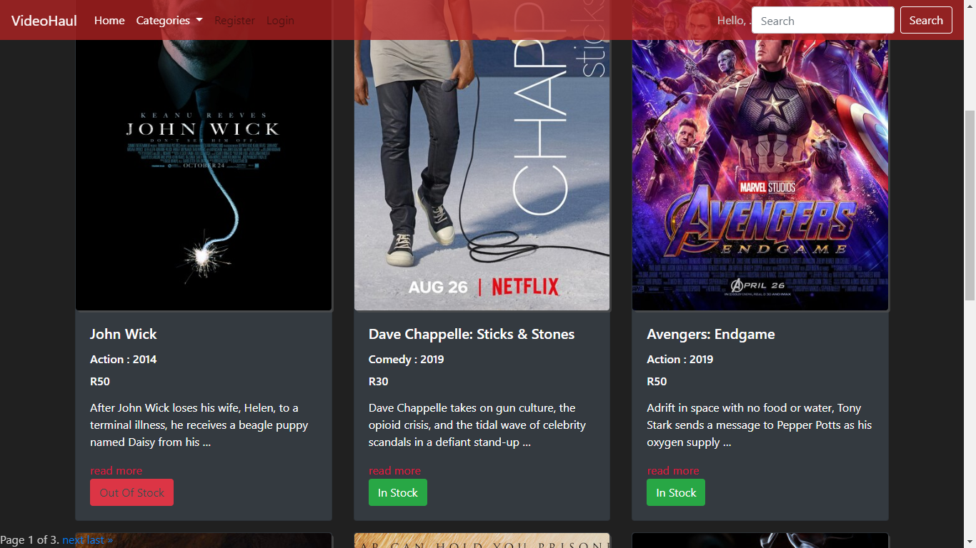

**Register screen:**

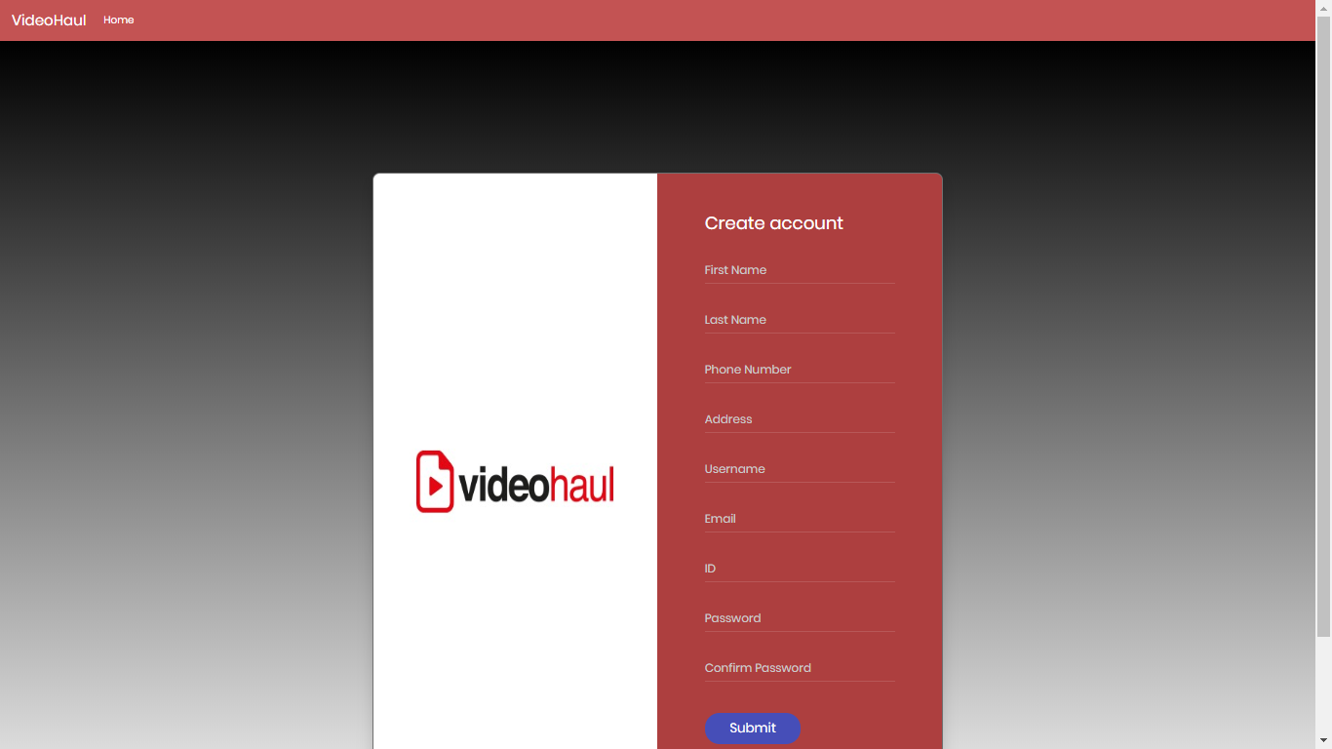

### A.2 Customer Workflow:

**Login screen:**

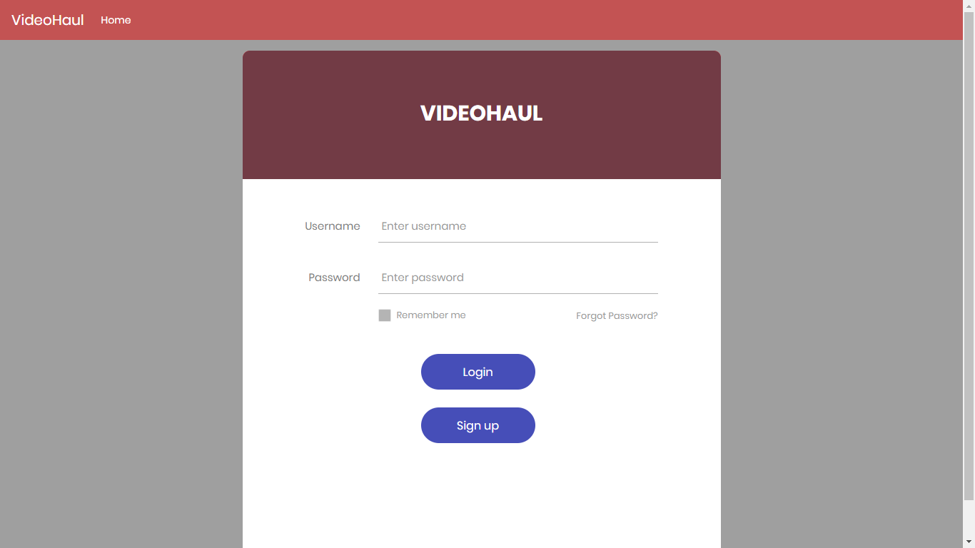

**Home screen:**

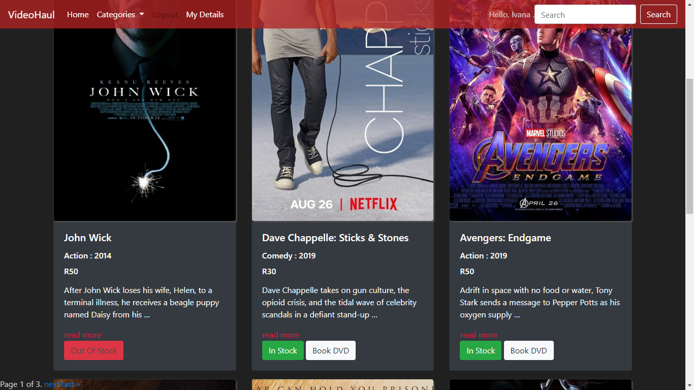

**User details screen:**

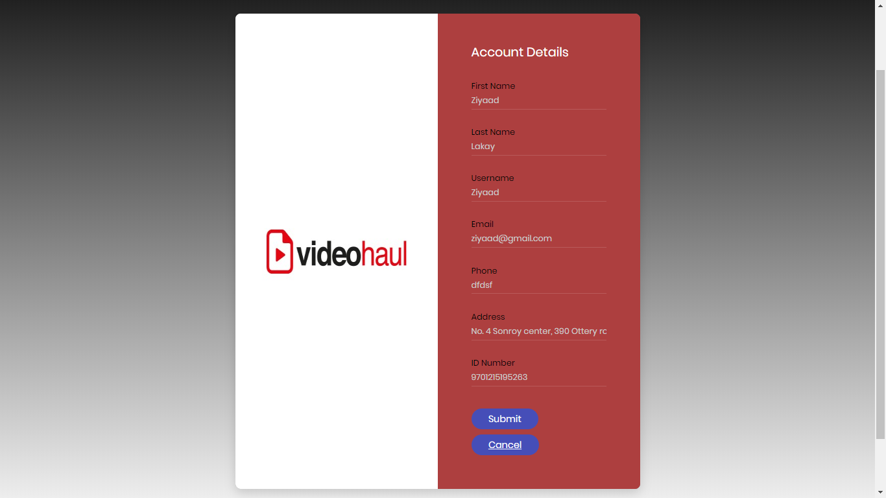

### A.3 Clerk Workflow:

**Home screen:**

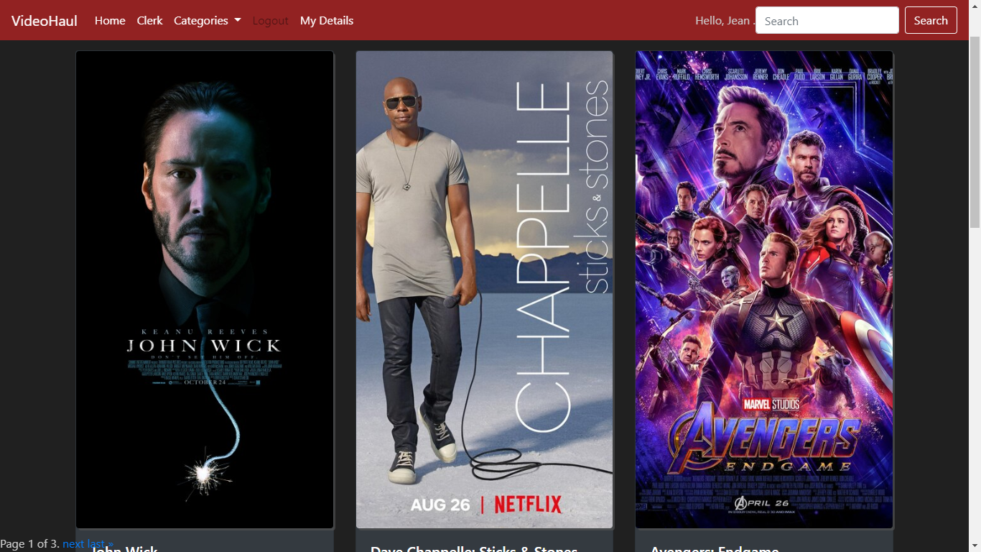

**Clerk screen:**

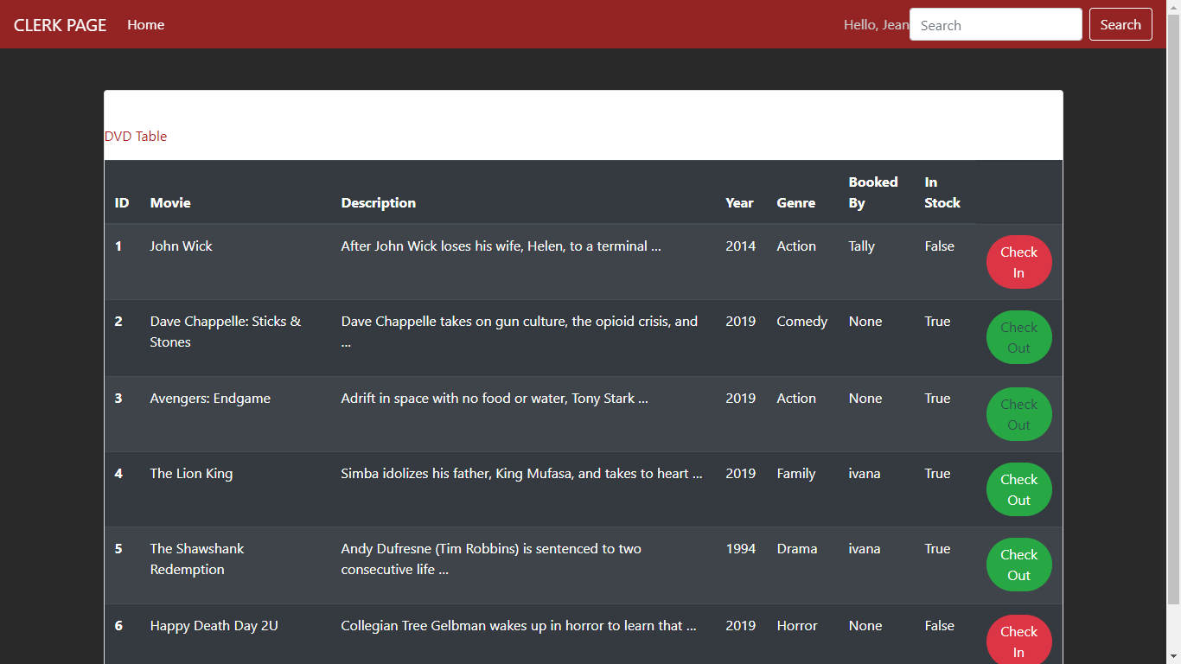

**User Details:**

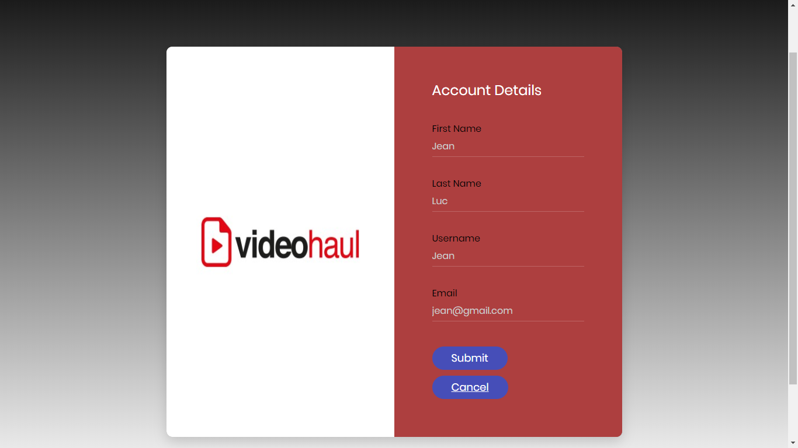

### A.3 Manager Workflow

**Home screen:**

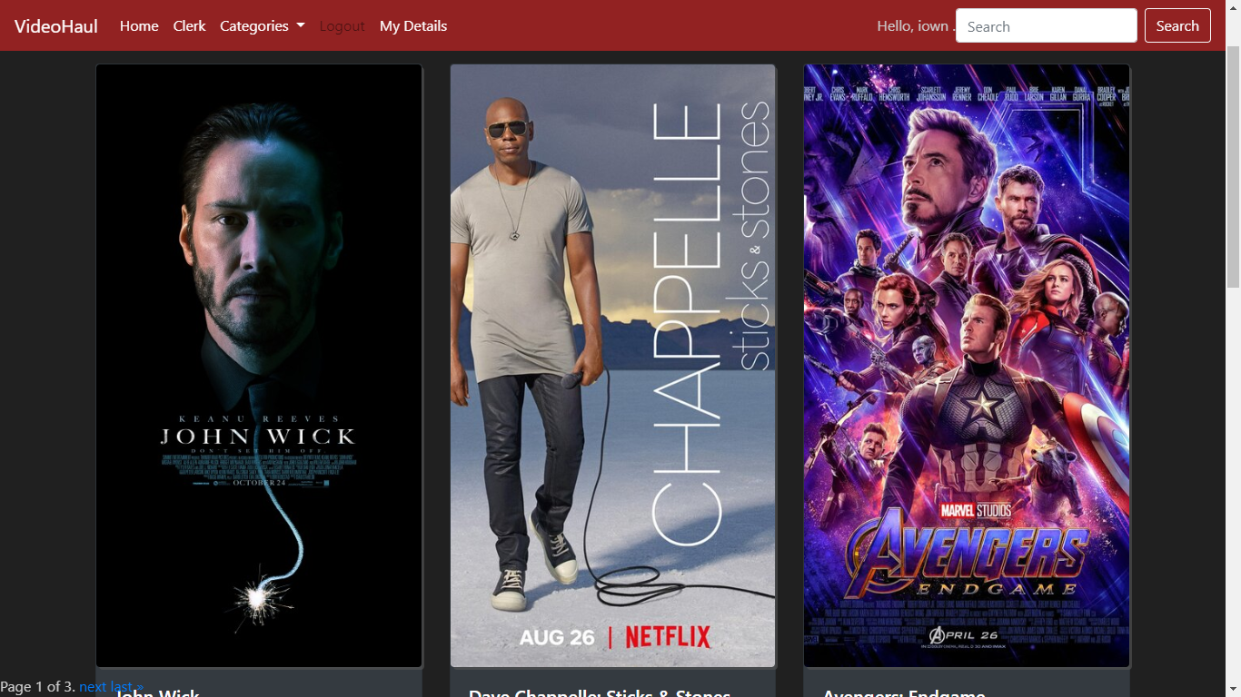

**Clerk screen:**

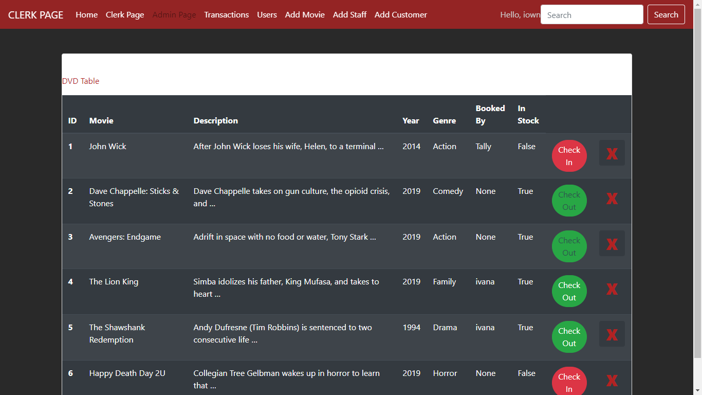

**Transactions screen:**

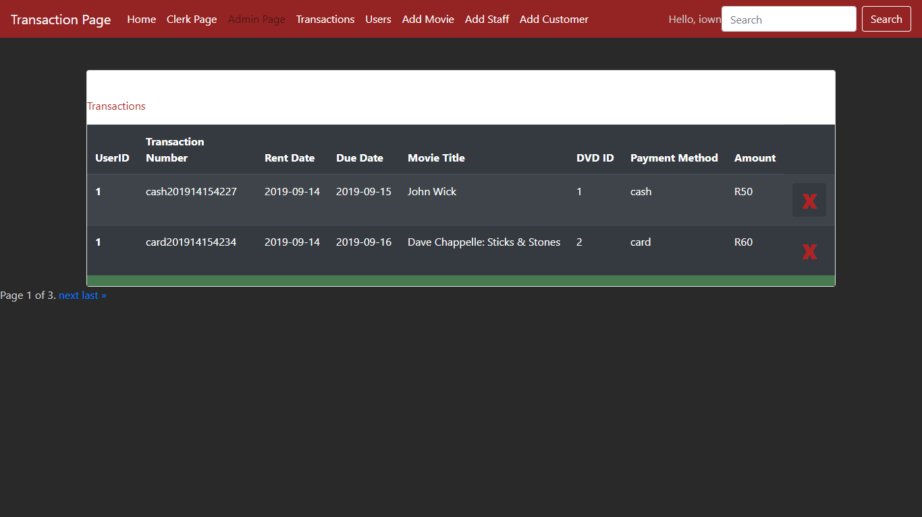

**Users screen:**

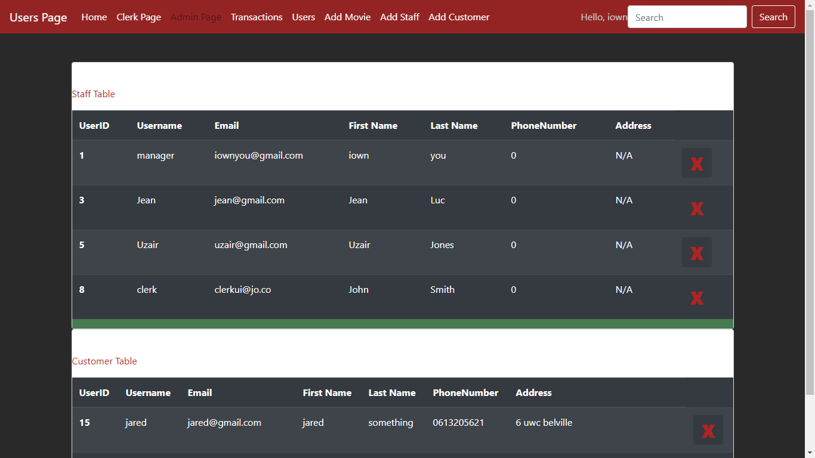

**Add movie pop-up:**

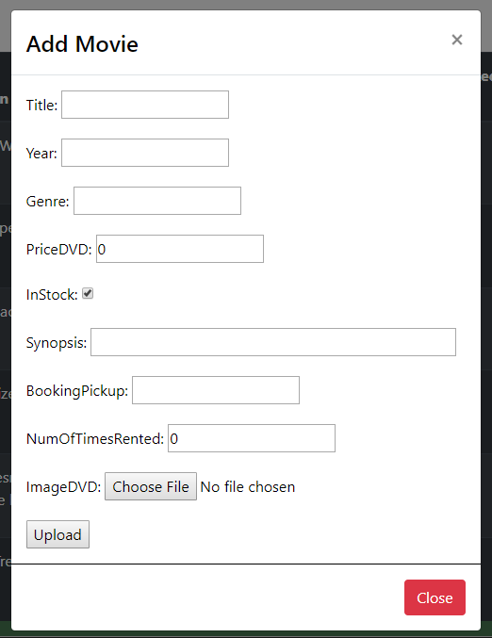

**Add staff pop-up:**

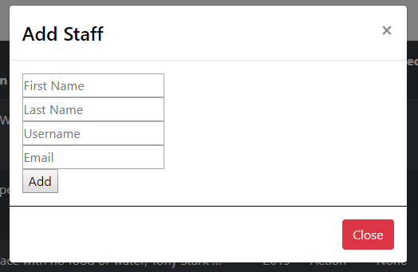

**Add customer pop-up:**

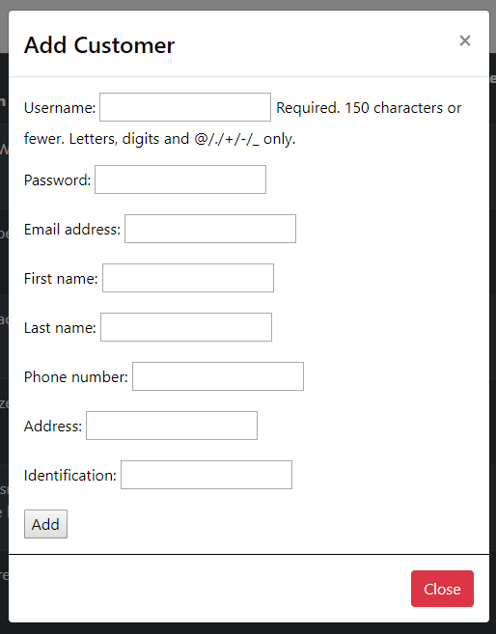

**Admin screen:**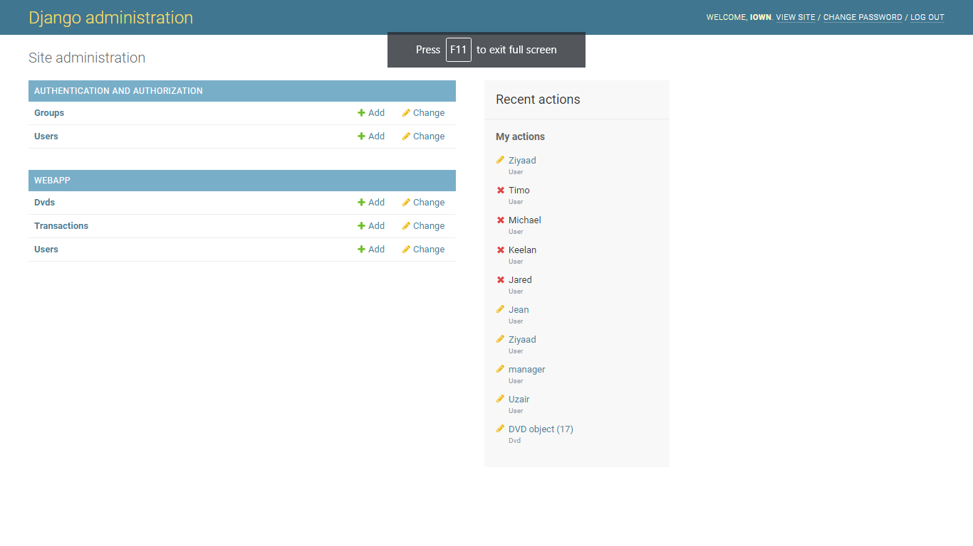

## Appendix B: Code

*The code segments listed below are only a critical portions of the entire code base, to access and see the entire code base in a more presentable and concise manner visit link below:

[**https://github.com/jeanluciradukunda/csc312.group.project**](https://github.com/jeanluciradukunda/csc312.group.project)

### B.1 Models (Database tables):

Here we will define our models, Like customer, employee etc. It will the be exported my django

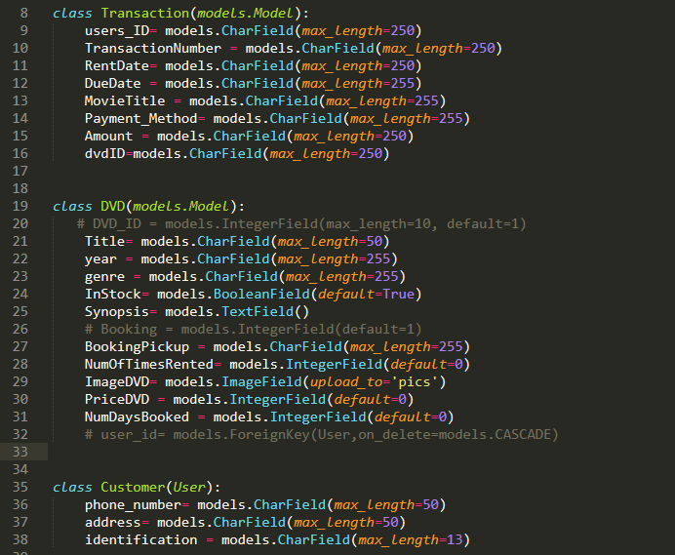

### B.2 URLS:

Define paths to our various views and web pages

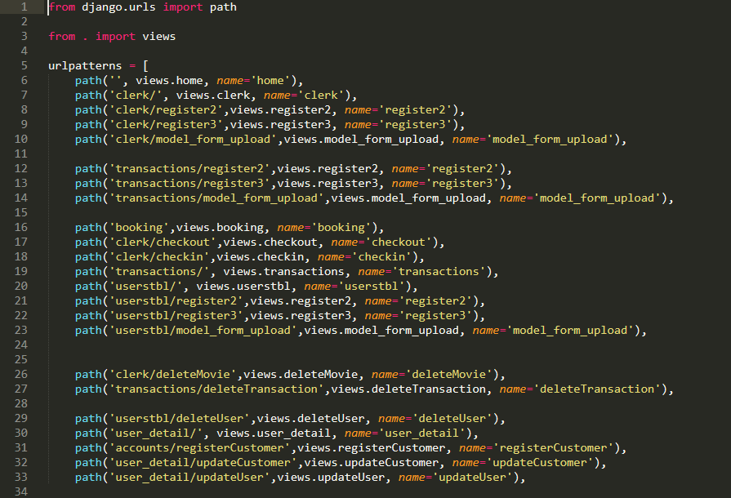

### B.3 Views:

Defining the functions that control the system.

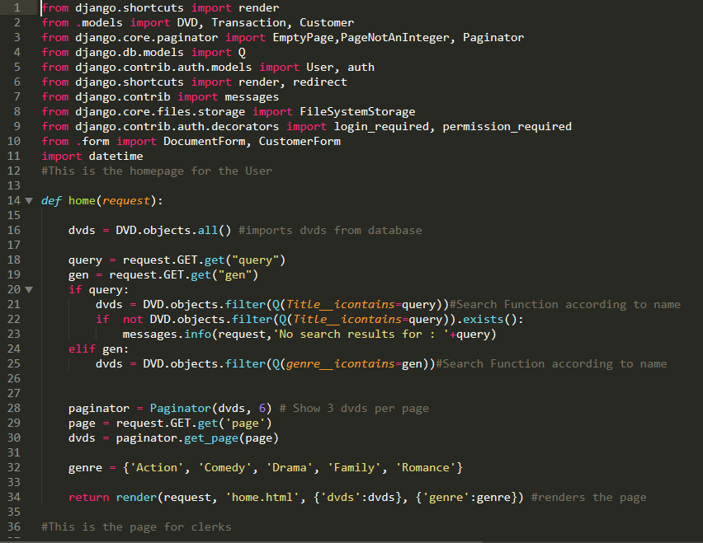

The end.